Security Implementation Report
1. Password Security (Hashing and Salting)
File: routes/authRoutes.js
User passwords are securely hashed and salted using bcrypt before being stored in the database. This ensures that plain text passwords are never saved and protects user credentials in the event of a data breach.
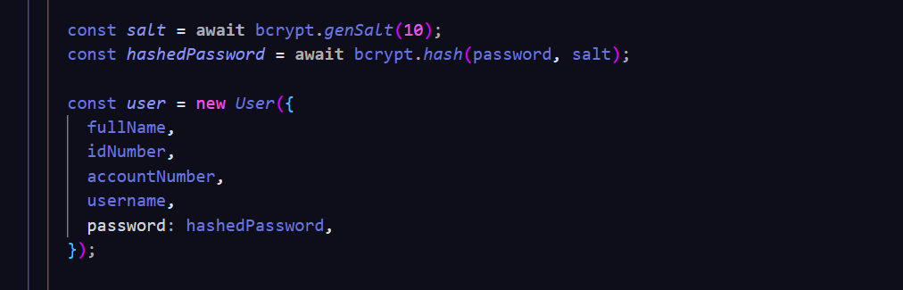
2. Input Validation (RegEx Whitelisting)
File: middleware/validators.js
Input validation is implemented using express-validator with Regular Expressions (RegEx). This ensures that only properly formatted input is accepted. Invalid or malicious input is rejected before processing, helping to prevent injection attacks and maintain data integrity.

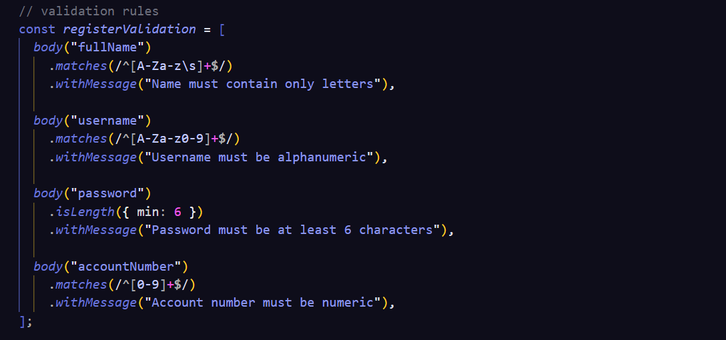

3. Authentication and Session Protection (JWT)
File: routes/authRoutes.js
Authentication is handled using JSON Web Tokens (JWT). A token is generated upon successful login and must be included in requests to protected routes. This ensures that only authenticated users can access sensitive functionality.

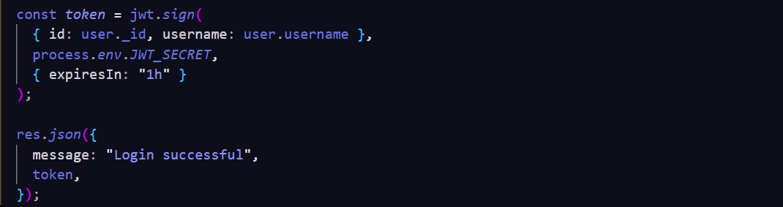

4. Protected Routes (Access Control)
File: routes/paymentRoutes.js
Sensitive routes are protected using authentication middleware. This ensures that only users with a valid JWT token are able to access and perform actions such as submitting payments.

5. Brute Force Protection (Rate Limiting)
File: server.js
Rate limiting is implemented using express-rate-limit to restrict the number of requests a client can make within a given time period. This helps prevent brute-force attacks and reduces API abuse.

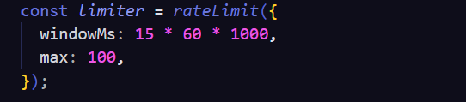
6. XSS and Clickjacking Protection (Helmet)
File: server.js
The application uses Helmet to set secure HTTP headers. These headers help protect against common web vulnerabilities such as Cross-Site Scripting (XSS) and clickjacking.


7. Man-in-the-Middle Protection (HTTPS)
File: Deployment Environment
The application is deployed over HTTPS, ensuring that all communication between the client and server is encrypted. This prevents attackers from intercepting or modifying sensitive data during transmission.

8. Database Security
File: config/db.js
The application uses MongoDB Atlas, a managed cloud database service. This provides built-in security features such as authentication, access control, and secure connections, reducing the risk of misconfiguration and unauthorized access.

Conclusion
The application implements multiple layers of security, including password hashing, input validation, authentication, protected routes, rate limiting, and secure HTTP headers. These measures collectively reduce the risk of common web attacks and ensure secure handling of user data.

AI Usage in Backend Development
Artificial Intelligence tools, specifically ChatGPT, were used to assist in the development of the backend components of the application.
The following tools and libraries were implemented with AI assistance:
- Node.js & Express – used to structure and build the backend API
- MongoDB Atlas – used for secure cloud-based database storage
- bcrypt – used for password hashing and salting
- jsonwebtoken (JWT) – used for authentication and session protection
- express-validator – used for input validation with RegEx
- Helmet – used to set secure HTTP headers and protect against XSS and clickjacking
- express-rate-limit – used to limit repeated requests and reduce brute-force attacks

Security Contribution of These Tools
These tools provide built-in security mechanisms:
- bcrypt ensures passwords are securely hashed and salted
- JWT ensures only authenticated users can access protected routes
- express-validator enforces strict input validation and prevents malicious input
- Helmet protects against XSS and clickjacking attacks through secure headers
- express-rate-limit helps prevent brute-force and excessive request attacks
- MongoDB Atlas provides authentication, access control, and secure database hosting

Why These Tools Are Safer
These tools are widely used, tested, and actively maintained. Using established libraries reduces the risk of vulnerabilities compared to writing custom security implementations. They follow industry best practices and minimize the likelihood of developer errors and misconfiguration.

Verification of AI Usage
All AI-generated suggestions were reviewed, tested, and validated before implementation. The backend functionality was tested using Postman and integrated with a frontend to ensure correct behavior.

